Batch: A1 Roll No.: 16010123012

Experiment / Assignment / Tutorial No.: 05

Grade: AA / AB / BB / BC / CC / CD /DD

Signature of the Staff In-charge with date

Title: Implementation of PGP-Based Secure Email Communication Using Mailvelope

______________________________________________________________________Objective: To implement public key cryptography using Mailvelope by generating key pairs, exchanging public keys, and sending encrypted and signed emails.
______________________________________________________________________
Expected Outcome of Experiment:
Course Outcome | After successful completion of the course students should be able to
 | Successful secure email communication through key generation, encryption, decryption, digital signatures, and file protection using PGP.
______________________________________________________________________
Books/ Journals/ Websites referred:
https://mailvelope.com/en/
______________________________________________________________________
Abstract:
This experiment is carried out to understand how secure email communication works using PGP and the Mailvelope extension. It involves generating public and private keys, exchanging public keys with peers, and sending encrypted and digitally signed emails. The activity also includes encrypting files and attachments to ensure that only authorized users can access the information. Through this hands-on practice, the concepts of confidentiality, integrity, and authentication in secure communication become clear and easy to understand.
Related Theory:
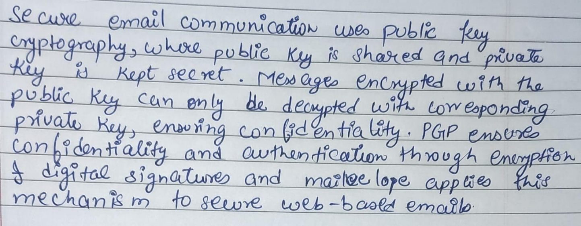
Implementation Details:
RSA:
Generating Key
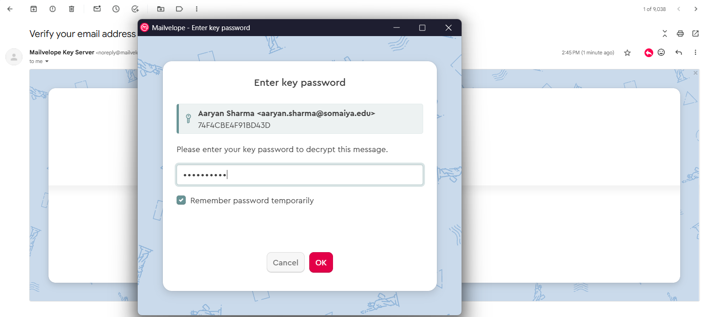
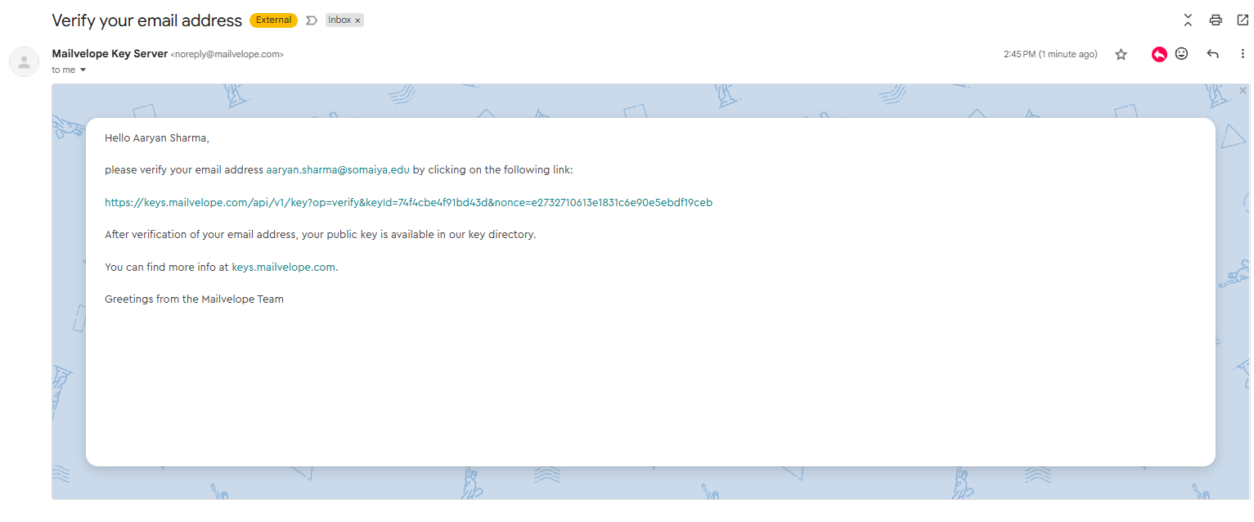
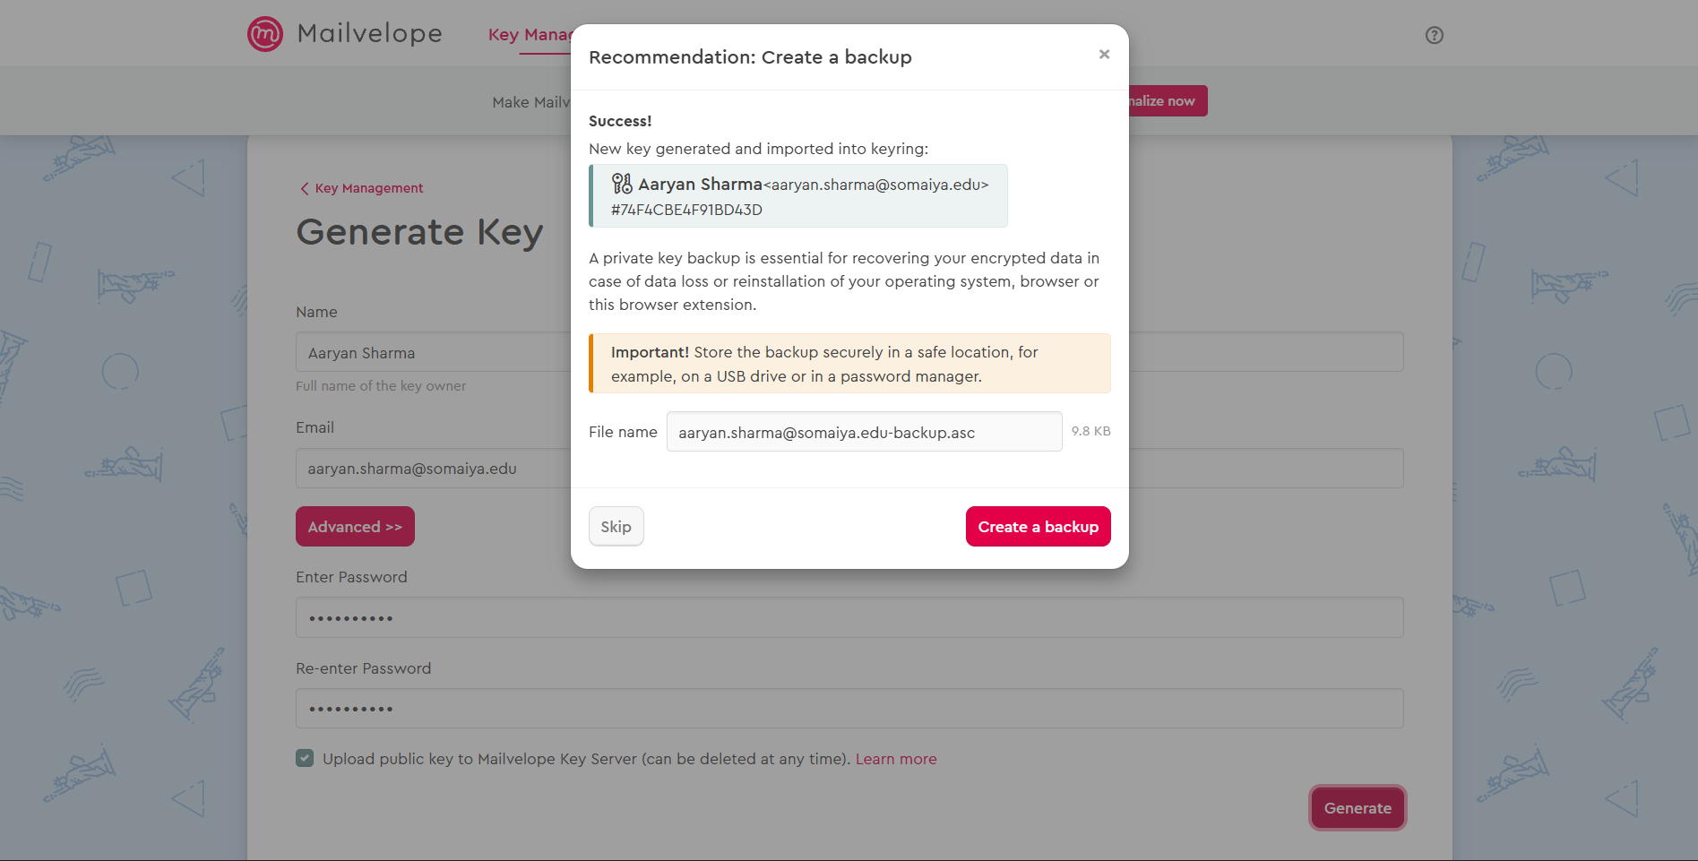
Exporting Key
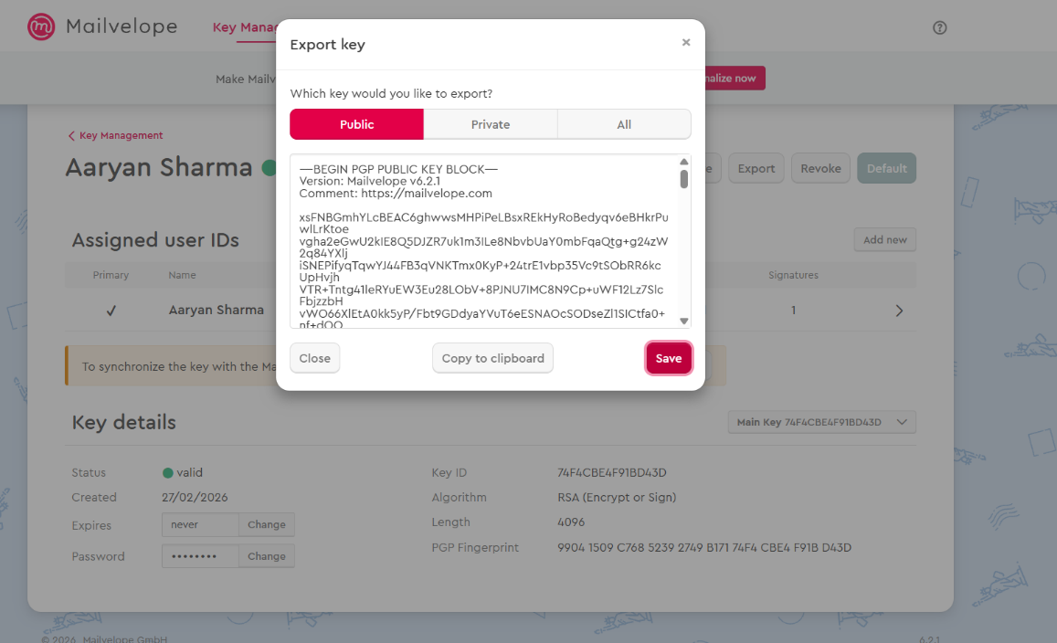
Importing others Key
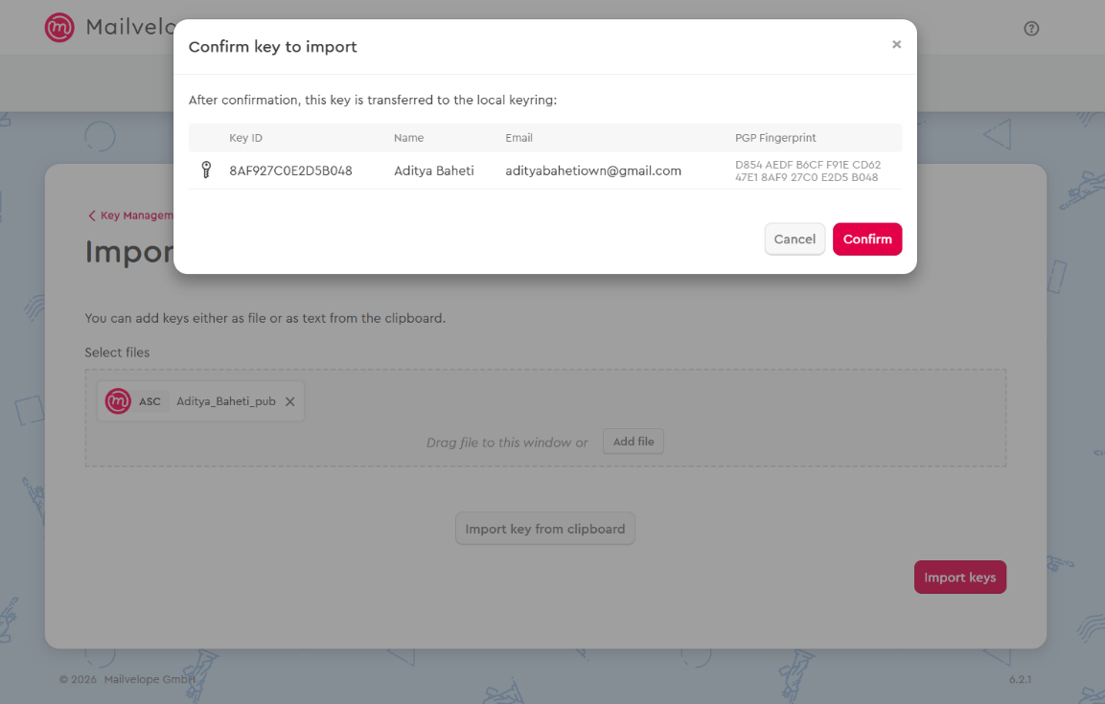
Sending Encrypted Message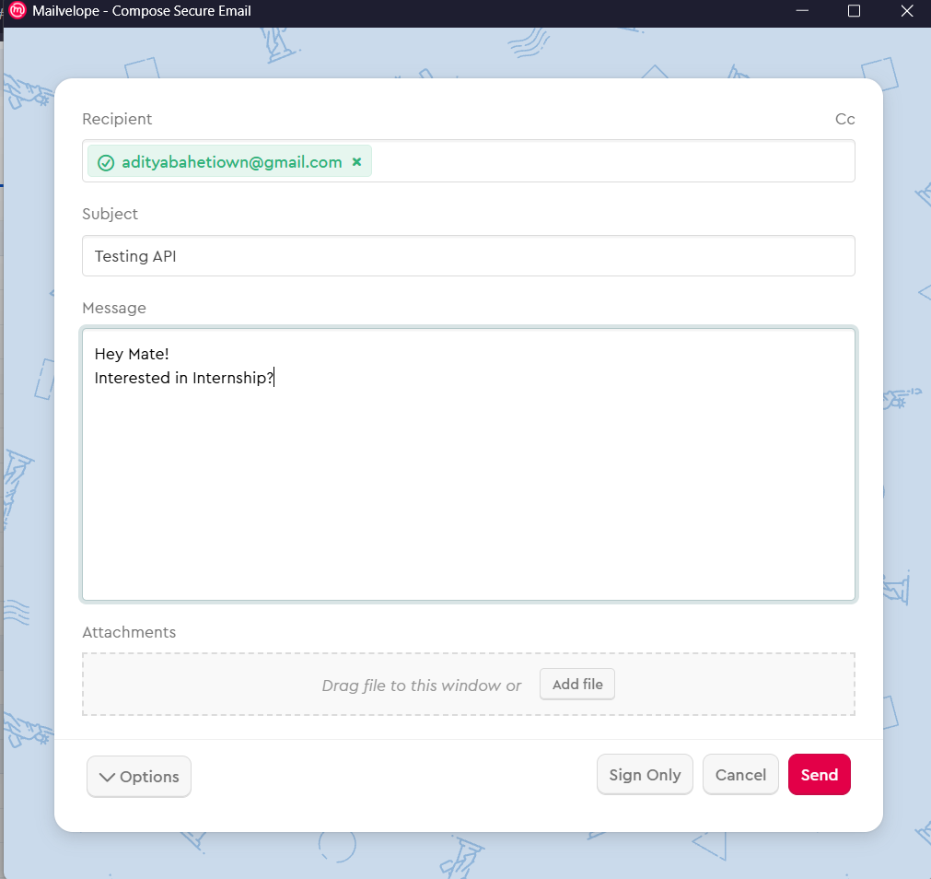

Receiving Email
ECC
Generating Key
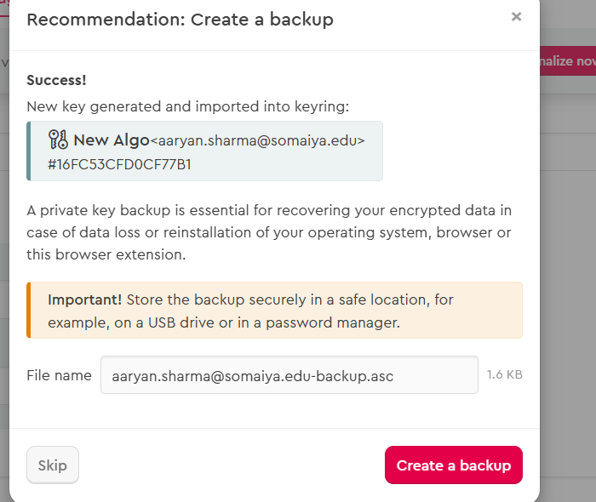
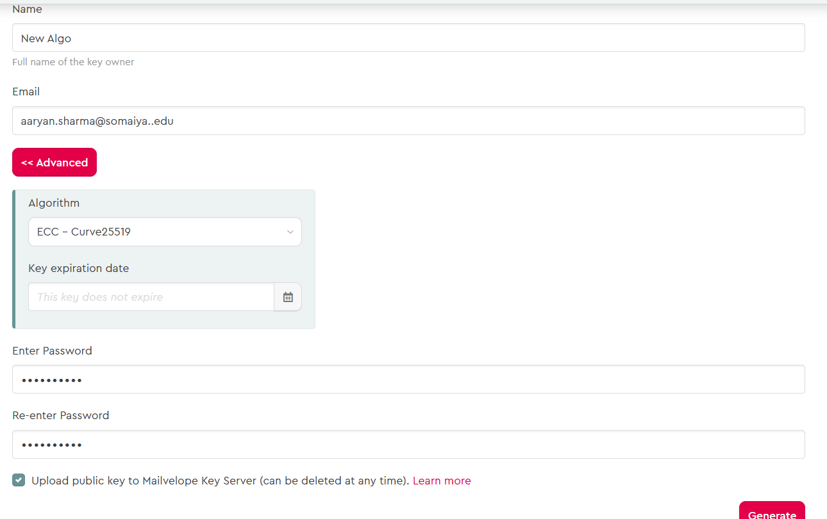
Exporting Key
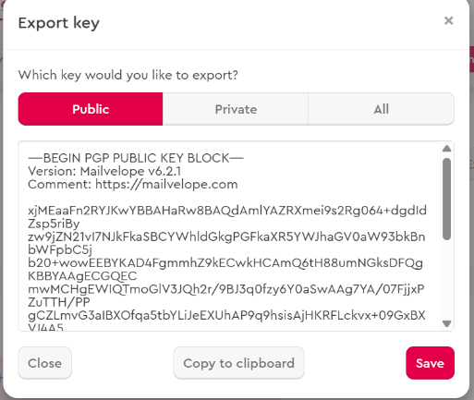
Importing Key
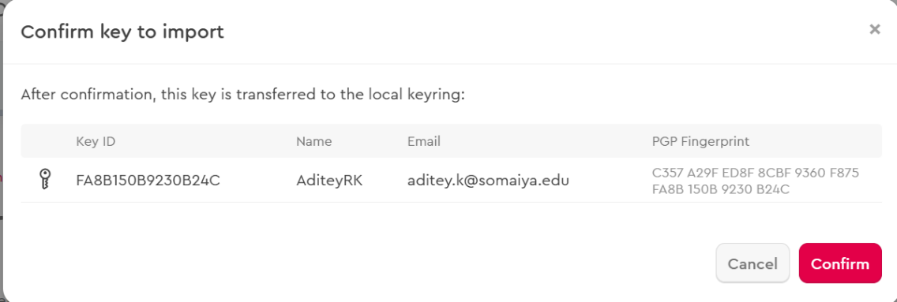
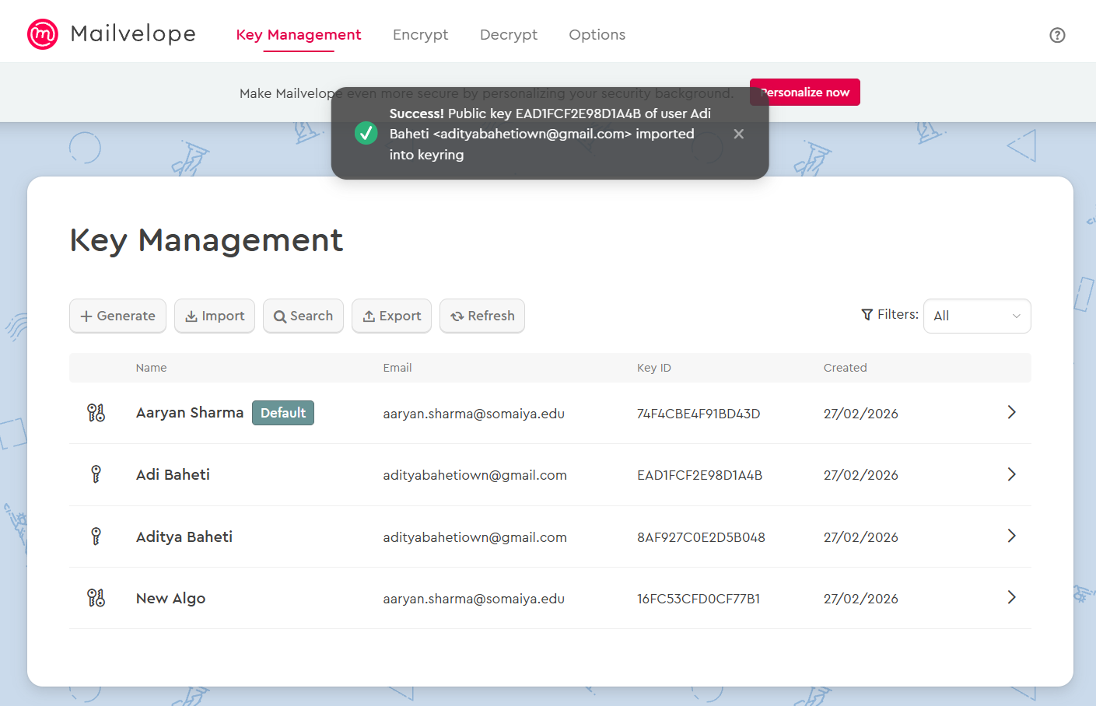
Sending Email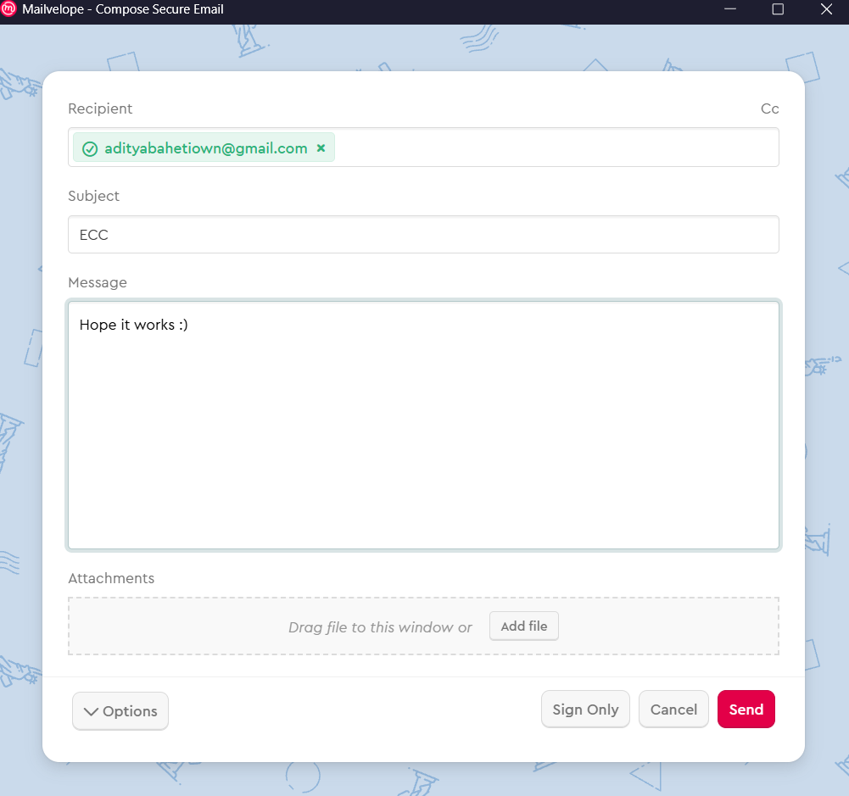
Receiving Email

Conclusion:
In this experiment, secure email communication was successfully implemented using PGP through the Mailvelope extension. Public and private key pairs were generated, public keys were exchanged, and encrypted as well as digitally signed emails were sent and received. The activity demonstrated how confidentiality is achieved through encryption, while digital signatures provide integrity and authentication. It provided practical understanding of public key cryptography in real-world secure communication systems.
Post-Lab Questions:
- Explain the steps to in PGP.
The main steps in PGP communication are:
1. Generate a public–private key pair.
2. Exchange public keys with the intended recipient.
3. Encrypt the message using the receiver’s public key.
4. Optionally sign the message using the sender’s private key.
5. Send the encrypted message.
6. Receiver decrypts using their private key and verifies the signature using the sender’s public key.
- How did you encrypt a message using the receiver’s public key?
The receiver’s public key was first imported into Mailvelope. While composing the email, the encryption option was selected and the receiver’s public key was chosen. Mailvelope then encrypted the message so that only the receiver, possessing the corresponding private key, could decrypt and read it.

- What output files were generated after encryption?
After encryption, the message was converted into an encrypted PGP block (ciphertext), typically shown as armored text beginning with “-----BEGIN PGP MESSAGE-----”. If files were encrypted, corresponding encrypted files with .asc or similar extensions were generated.

